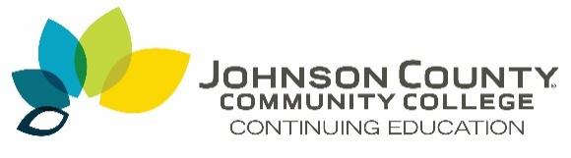

Coronavirus Relief Funds Available for Johnson County Individuals

OVERLAND PARK, Kan. – The Johnson County Community College (JCCC) Continuing Education branch is proud to announce a partnership with county initiative JOCO KS Works to provide access to free workplace skills training for those who have been financially affected by COVID-19.

The program is funded through the federal government's Coronavirus Aid, Relief, and Economic Security (CARES) Act, and is designed to pay for training and skill-building for Johnson County residents and businesses who have experienced job loss, cut wages or reduced revenue due to the COVID-19 pandemic.

Those who qualify and complete the application process can register free of charge for any of the more than 350 courses in categories that include Healthcare, Leadership, Manufacturing, Information Technology, Finance, Project Management and more. Students who enroll through the program must complete their training by December 30, 2020.

Additionally, businesses located in Johnson County that had to cut back staff, wages, furlough employees or have a need to reskill their workforce because of COVID-19 could also qualify for CARES training funds through the JOCO KS Works program.

“From training in computer software, to business leadership, to the trades, these courses provide individuals with the opportunity to learn new skills and build on those they already use in the workplace. For businesses, JCCC courses can help upskill their employees, ultimately creating the demand for new jobs. This support of workforce training by Johnson County is unprecedented, allowing JCCC to fulfill our mission of inspiring learning to transform lives and strengthen communities,” said Elisa Waldman, Dean, Continuing Education.

Funding is available until exhausted and classes will fill quickly! To view all JCCC qualified courses and apply, visit jccc.edu/CaresAct.

