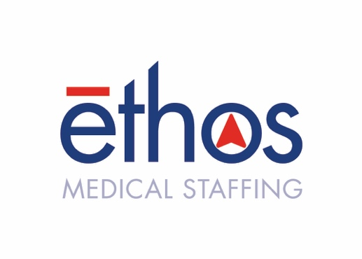

For Immediate Release
September 1, 2021
Contact: Craig Brenner
(816)-509-7786 | craig@ethosmedicalstaffing.com

Kansas City Business Journal Names Ethos Medical Staffing as ‘Best Places to Work’ finalist on heels of Inc. 5000 ranking

Lenexa, Kan. — The Kansas City Business Journal announced that local travel nursing firm Ethos Medical Staffing has been selected as a finalist for the 2021 Best Places to Work awards.

This accolade also comes on the heels of an Inc. 5000 ranking for Ethos in mid-August. At No. 2,418 with a three-year revenue growth of 175%, Ethos ranked in the top half of the list, which recognizes the nation’s fastest-growing private companies.

The 47 companies honored this year as Best Places to Work are divided into five categories: extra small, small, medium, large, and extra-large. Ethos has placed as one of 16 finalists in the “extra-small companies” category.

Based on employee survey results conducted through survey partner Quantum Workplace, the KCBJ’s Best Places to Work awards program honors companies with high employee satisfaction rates, perks and benefits, advancement opportunities and positive company culture. Finalists will be celebrated at an awards event held Nov. 3 at Arrowhead Stadium.

Among other employee perks, Ethos offers its nurses a 401(k) plan, a full benefits package, and tax-free stipends for food, lodging and incidentals. The firm also strives to increase its nurses’ net income by 100 to 150 percent to provide them resources to grow personally and professionally.

“We are thrilled to be a finalist for Best Places to Work in Kansas City,” said Jeff Stoner, CEO and President of Ethos Medical Staffing. “We strive to be the best staffing firm in Kansas City and our employees take pride in that. It’s truly a team effort and having everyone move in the same direction has made it possible. I’m beyond proud of our team.”

This accolade also comes on the heels of an Inc. 5000 ranking for Ethos in mid-August. At No. 2,418, Ethos ranked in the top half of the list, which recognizes the nation’s fastest-growing private companies.

For more on Ethos, visit ethosmedicalstaffing.com.

About Ethos Medical Staffing
Founded by nurses in 2015, Ethos Medical Staffing is improving communities by changing how health care is delivered. Ethos is a family-oriented traveling nursing firm focused on the communities it serves, guided by a common belief that nurses and allied health professionals deserve an advocate who treats them like a priority while they care for others. To learn more, visit ethosmedicalstaffing.com.

###

